Maegan Brown, M.A.Ed., LPCA

Office: 828-222-0401
Fax: 888-595-9450
Cell: 828-708-7088 (call or text)
E-mail: Maegan@fullcirclewnc.org

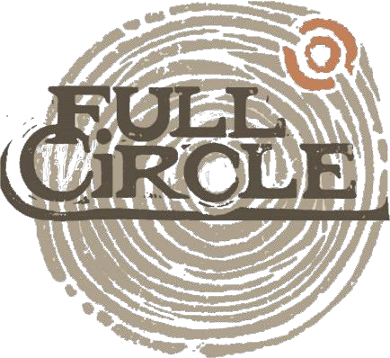

PROFESSIONAL DISCLOSURE STATEMENT & INFORMED CONSENT
This is a professional disclosure statement required by the Standards of Practice of the North Carolina Board of Licensed Professional Counselors (NBLPC).

My Qualifications

I graduated with my M.A.Ed. in School Counseling from Western Carolina University in May 2011. I currently hold a license in Professional School Counseling (my license number is 1169240); my license expires in June 2024. I am also a Licensed Professional Counselor Associate and my license number is A14273; this license expires in June 2020. I have 5 years of counseling experience.

Restricted Licensure

As a Licensed Professional Counselor Associate, I am supervised by a clinical supervisor. Their name and contact information is below. I meet with my supervisor bi-weekly to ensure I am providing the best care to all of my clients. With client permission, some sessions may be audio recorded for case presentation during supervision. These recordings are held confidential and are erased directly after presentation. These recordings are for the sole purpose of improving and evaluating my work as a professional counselor.

Matthew Snyder (License number S7725)- (828) 290-9602

`

Counseling Background

I was employed as a Professional School Counselor from 2013-2019 working with children and adolescents ages 5-18, kindergarten through twelfth grade.

Full Circle has given me the opportunity to expand my professional experience and work with children, adolescents, adults, couples, and families on a variety of presenting issues including but not limited to: LGBTQIA+, mental health concerns, grief and loss, divorce, self-injurious behavior, suicidal ideation, and other life stressors.

Although I tailor my approach to the individual client, I use a variety of treatment modalities including but not limited to Cognitive Behavioral Therapy (CBT), Dialectical Behavior Therapy (DBT), Motivational Interviewing, Brief-Solution Focused Therapy, and Trauma-Focused CBT.

Session Fees and Length of Service

The length of each session is approximately 53 minutes, which includes payment of session and scheduling. If you need to cancel an appointment, please do so within 24 hours before your scheduled appointment time. You may email, text, or call me to cancel or reschedule your appointment. In order to fill empty appointment slots in a timely manner, I charge a fee of $50 for all missed appointments or appointments cancelled less than 24 hours. My rates for services are as follows:

Fees:
Initial evaluation and diagnostic (Completed during the first session) | $125/53 minutes
Individual | $100/53 minutes
Family therapy | $100/53 minutes

I am currently in network with Blue Cross Blue Shield and I am able to bill directly for our sessions. As a client, you are responsible for your copay, or the full amount of each session (if necessary). If you do not have insurance (or I am not in network with your insurance provider), and you are unable to pay the full the rate for services, please inform me prior to our first session and we can discuss an adjusted rate for services. At Full Circle, we are dedicated to making counseling accessible to everyone and regularly provide services at reduced rates when necessary. If you are paying a reduced rate for services, your fee will be $________.
I accept checks and most credit cards (Visa, MasterCard, American Express, Discover, JCB, and Union Pay).

Use of Diagnosis

Some health insurance companies will reimburse clients for counseling services and some will not. In addition, most will require that a diagnosis of a mental-health condition and indicate that you must have an “illness” before they will agree to reimburse you. Some conditions for which people seek counseling do not qualify for reimbursement. If a qualifying diagnosis is appropriate in your case, I will inform you of the diagnosis before we submit the diagnosis to the health insurance company. Any diagnosis made will become part of your permanent insurance records.

Confidentiality

All of our communication becomes part of the clinical record, which is accessible to you upon request. I will keep confidential anything you say as part of our counseling relationship, with the following exceptions: (a) you direct me in writing to disclose information to someone else, (b) it is determined you are a danger to yourself or others (including child or elder abuse), (c) I am ordered by a court to disclose information, (d) or you are a child or adolescent that is being harmed.

For clients under 18 years of age, it is vital to the therapeutic relationship that the client trust the therapist and feel that therapy is a safe place to disclose information they might not otherwise. Because of this, I ask permission from each of my clients before disclosing any information to their parents or guardians unless it is an exception mentioned above.

Emergency Support

If you are experiencing a mental health emergency, you have three options for assistance:
- Call 911
- Go to the nearest Emergency Room
Asheville: Mission Hospital Hendersonville: Pardee or Park Ridge Hospitals
- Call the Western Highlands Access and Crisis Number which is operational 24 hrs a day/ 7 days a week. For Buncombe, Henderson and Polk Counties, call 828.225.2800 Mon-Fri 8:30 Am to 5 PM and 1- 800-951-3792 after that.

Complaints

Although clients are encouraged to discuss any concerns with me, you may file a complaint against me with the organization below should you feel I am in violation of any of these codes of ethics. I abide by the ACA Code of Ethics (http://www.counseling.org/Resources/aca-code-of-ethics.pdf).

North Carolina Board of Licensed Professional Counselors
P.O. Box 77819
Greensboro, NC 27417
Phone: 844-622-3572 or 336-217-6007
Fax: 336-217-9450
E-mail: Complaints@ncblpc.org

Acceptance of Terms

We agree to these terms and will abide by these guidelines.

Client: __________________________________________________________________ Date: _______________________

Parent/Guardian: ______________________________________________________ Date:________________________
(if applicable)

Counselor: _____________________________________________________________ Date: _______________________

